

**IBM Data & AI**

**Auto AI**

© Copyright IBM Corporation 2018

IBM, the IBM logo, ibm.com, and IBM Watson are trademarks of International Business Machines Corp., registered in many jurisdictions worldwide. Other product and service names might be trademarks of IBM or other companies. A current list of IBM trademarks is available on the Web at “Copyright and trademark information” at www.ibm.com/legal/copytrade.shtml.

This document is current as of the initial date of publication and may be changed by IBM at any time. Not all offerings are available in every country in which IBM operates.

THE INFORMATION IN THIS DOCUMENT IS PROVIDED “AS IS” WITHOUT ANY WARRANTY, EXPRESS OR IMPLIED, INCLUDING WITHOUT ANY WARRANTIES OF MERCHANTABILITY, FITNESS FOR A PARTICULAR PURPOSE AND ANY WARRANTY OR CONDITION OF NON-INFRINGEMENT. IBM products are warranted according to the terms and conditions of the agreements under which they are provided.

Contents

Exercise 1: Predict in 20 minutes 4

# Exercise 1: Create a machine learning model using Auto AI

Use Case

**Goal: Approach:**

Identify who has high probability to cancel the contract (Churn) to help marketing team to create a list of customer targets to receive specific marketing campaign

* Automatically generate a model to identify who has cancel
* Review results

**Why?**

To save marketing cost and reduce the customer churn, identify those likely to churn and focus marketing efforts on those customers.

Auto AI

1. Add the AutoAI experiment to the project. Click on **+ Add to project**.
2. Click on **AutoAI**.

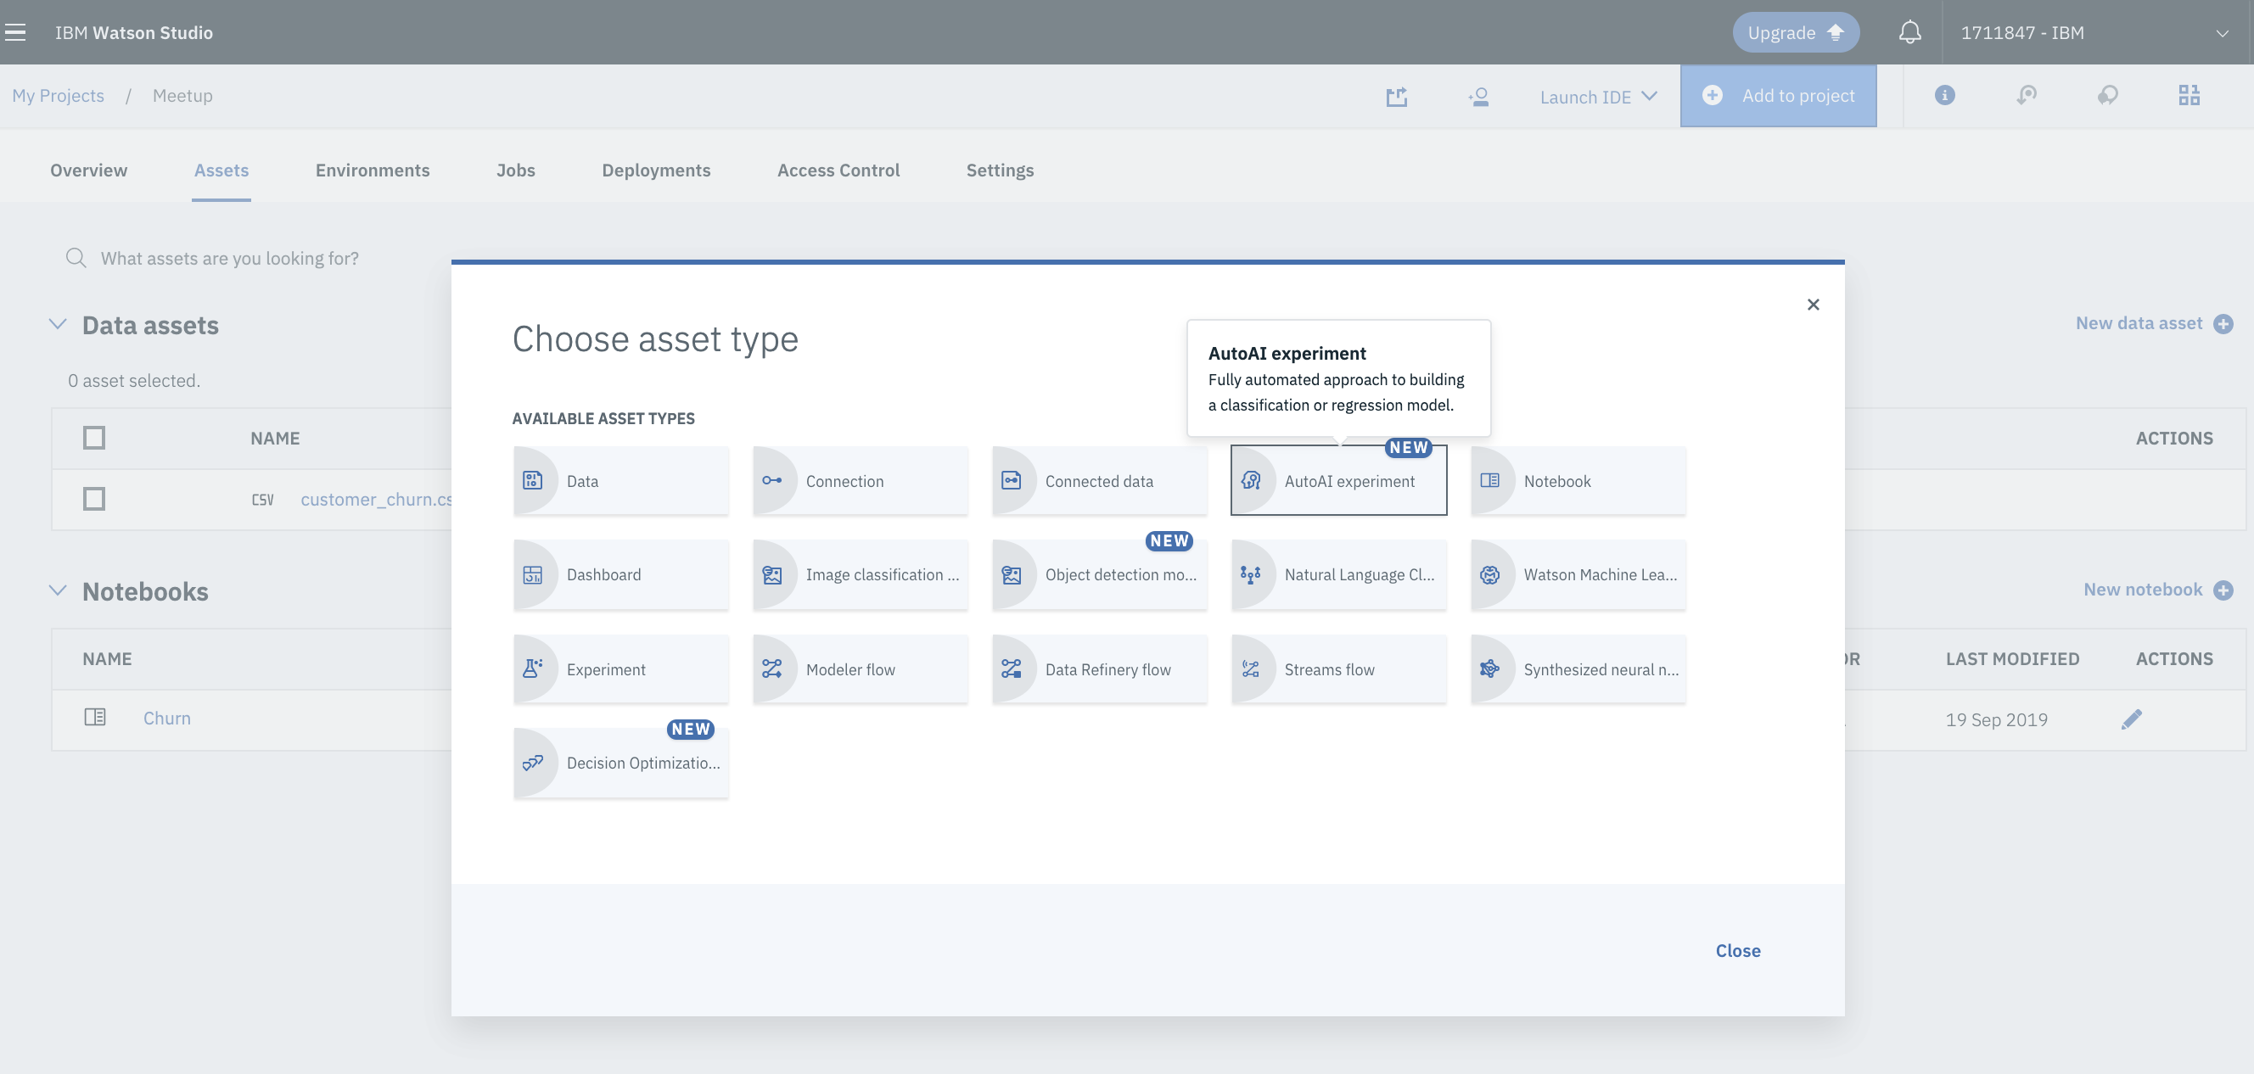

1. Type the **Asset name** and use the option “**From blank**”.

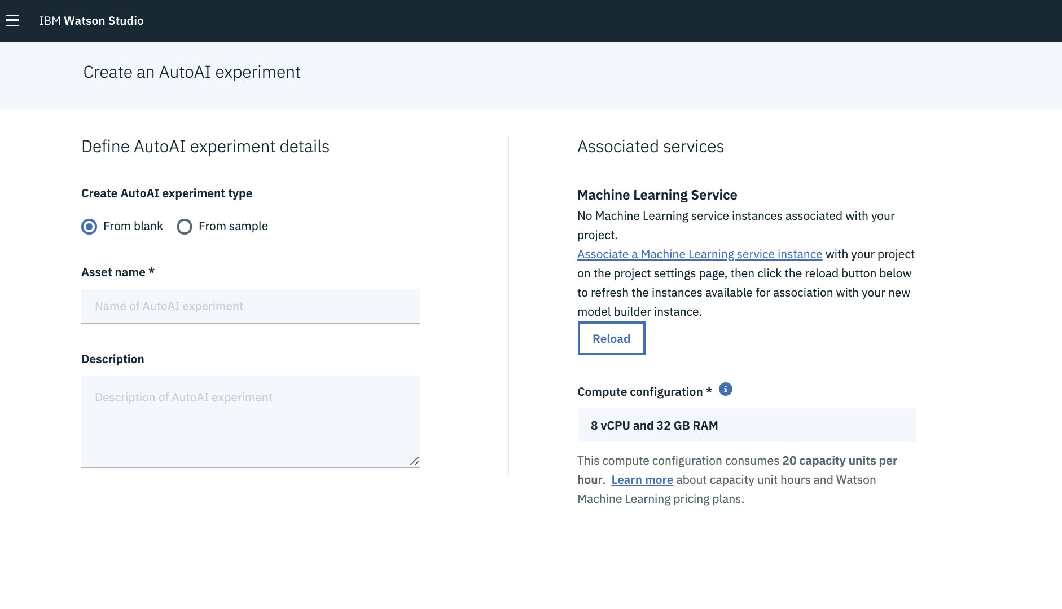

1. Click on “[Associate a Machine Learning service instance](https://dataplatform.cloud.ibm.com/data/discovery/predictive-modeling/picker?target=ml&tab=new&closeTab=true&projectId=b26c6822-aa78-476e-a126-496f3b7a3ae0&context=analytics)” to select the machine learning service instance. Click **Select**.

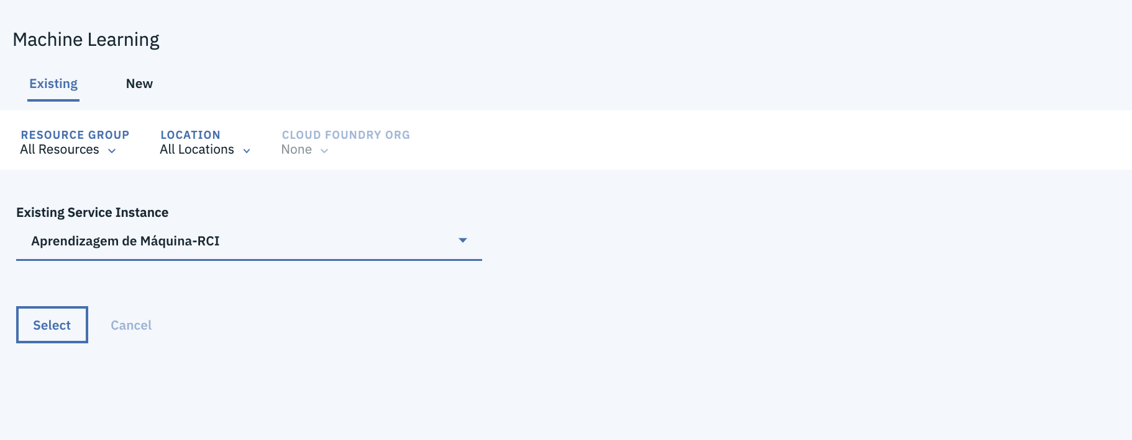

1. Click in **Create**

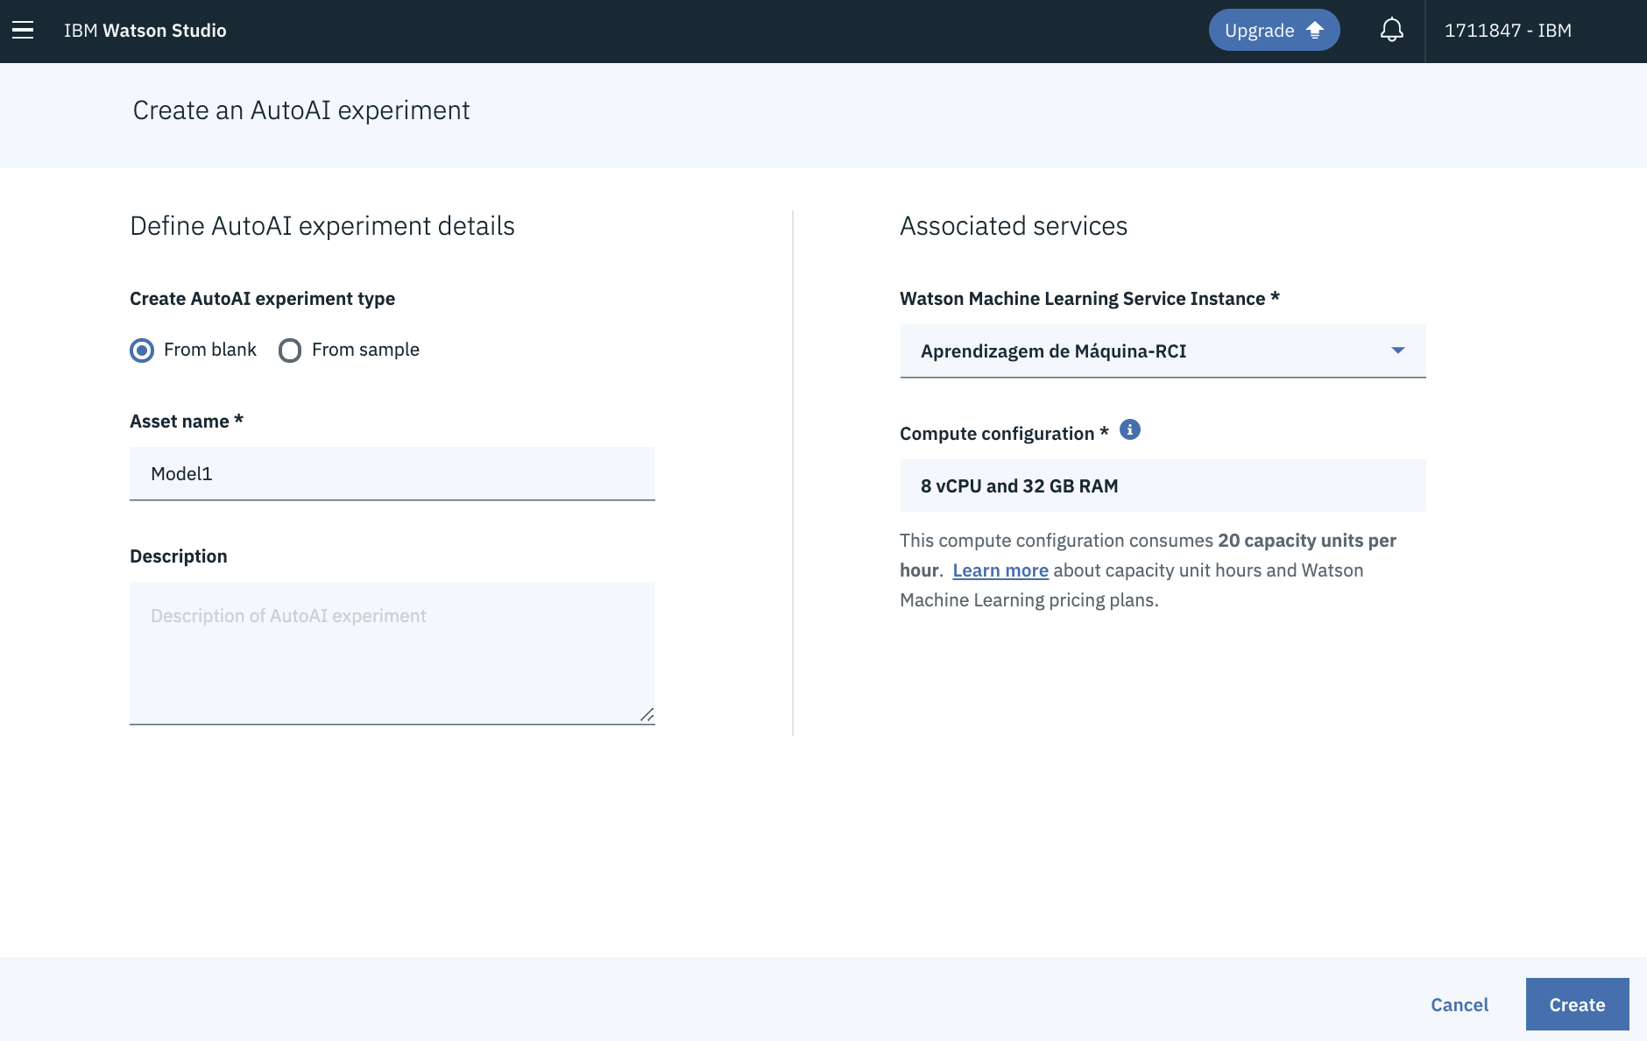

1. Click on **Select from project** to select the **customer_churn.csv** file already load in the project. Click **Select asset**.

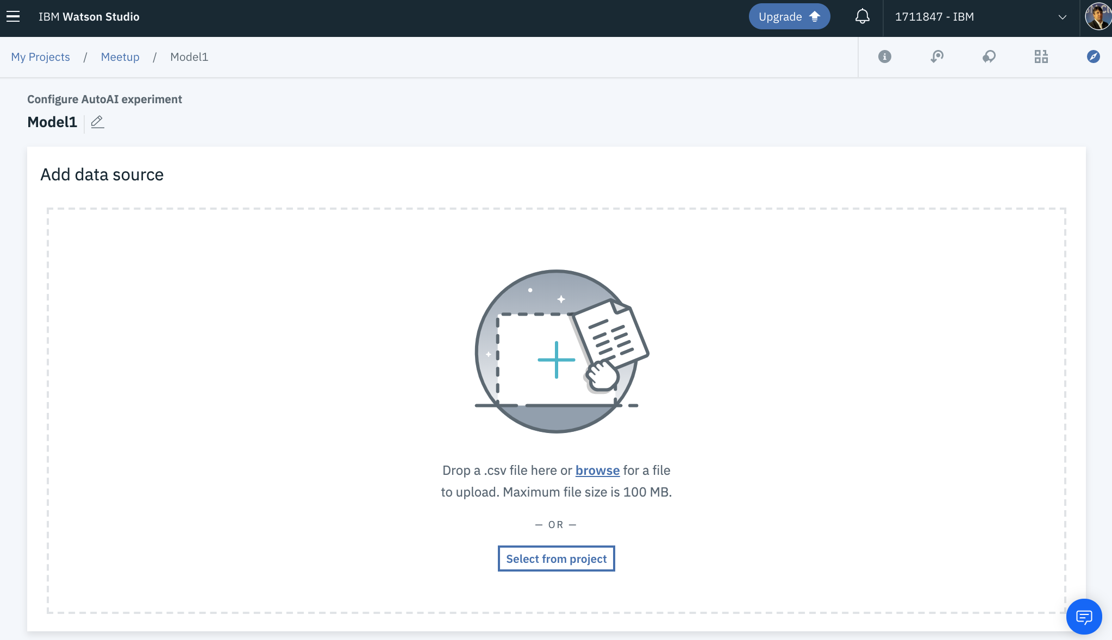

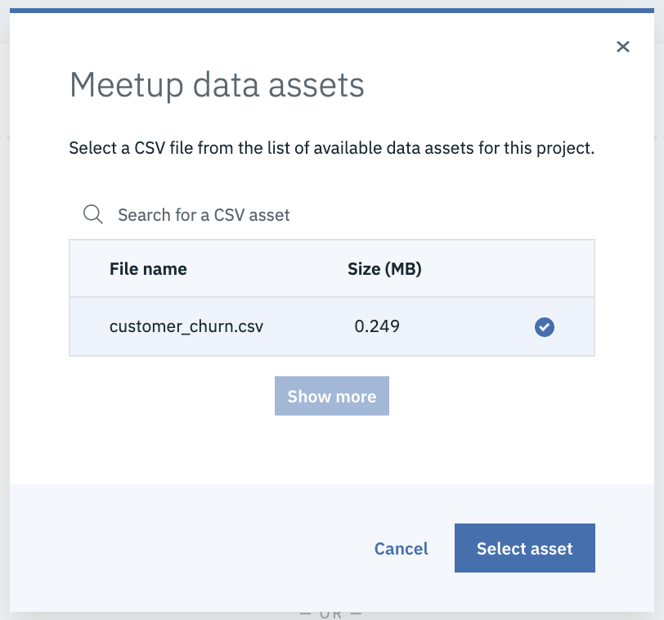

1. Select the CHURN column, on Select column to predict and click **Run experiment.**

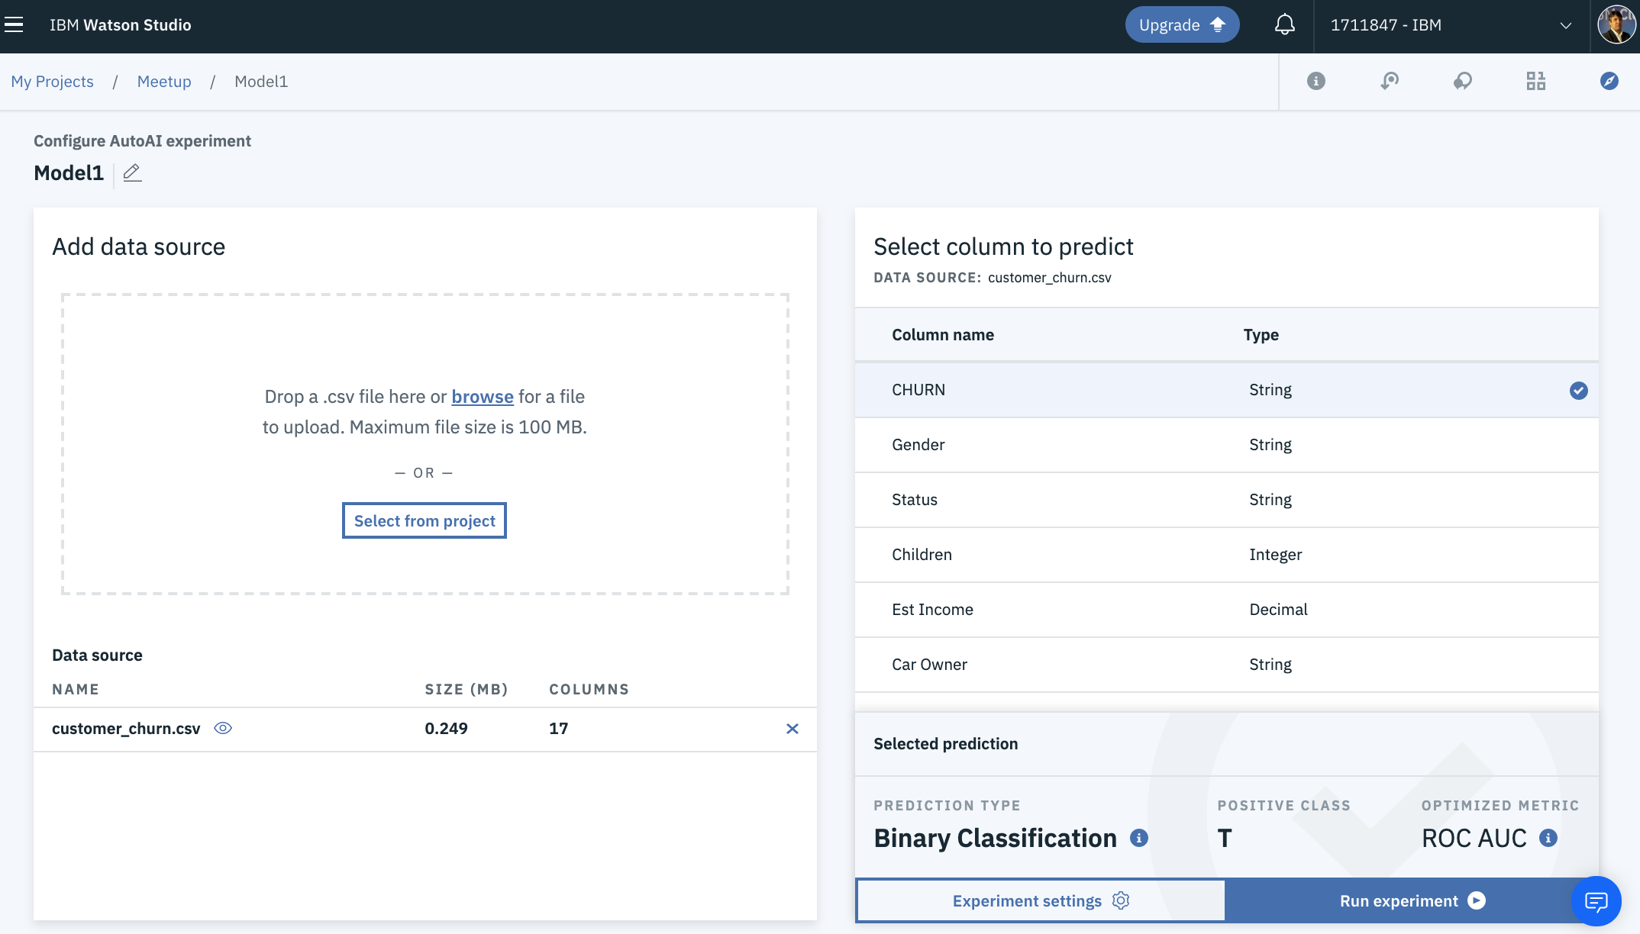

1. Choose the best model and click on **Save as model**.

